📀 DVD Rental PostgreSQL Project 📀
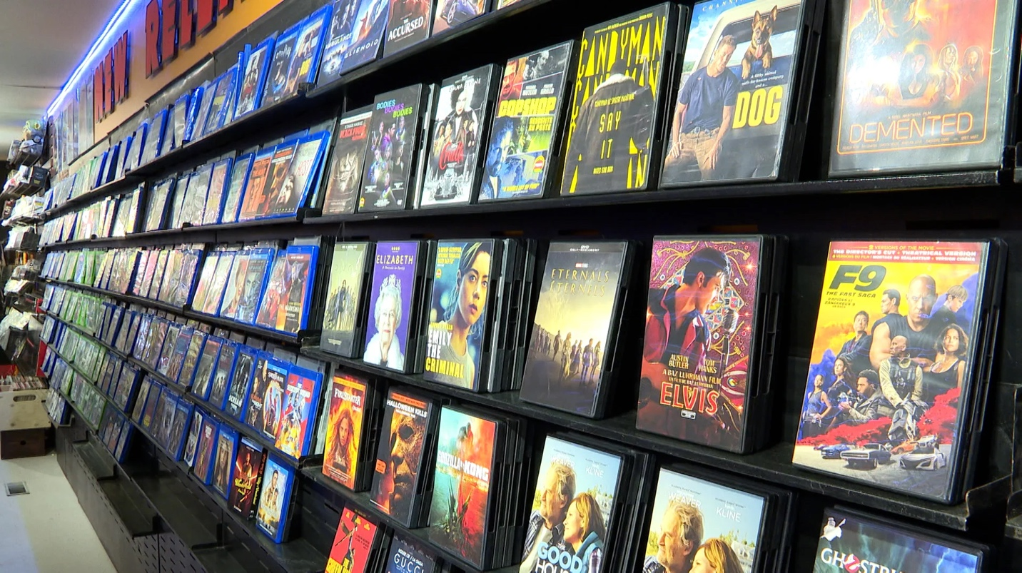

📚 Introduction
Welcome to the DVD Rental Database Project, a hands-on application of PostgreSQL, the powerful open-source object-relational database system. 🎓
This project encapsulates 15 meticulously designed tables: 'actor', 'film', 'film_actor', 'category', 'film_category', 'store', 'inventory', 'rental', 'payment', 'staff', 'customer', 'address', 'city', and 'country'. Each table represents various facets of a real-world DVD rental business. 📊
As you navigate through this project, you'll gain practical insights into the capabilities of PostgreSQL, refine your database management skills, and understand complex data structures and relationships. Welcome to a learning journey that unravels the intricate operations of a DVD rental store. 🚀

🎯 Objective
- Implement SQL querying techniques to explore and manipulate the data.
- Utilize PostgreSQL database system for managing and interacting with the data.
- Leverage Git commands for version control and effective collaboration.

🔧 Tool: PostgreSQL 14

📃 DVD Rental Database Tables
There are 15 tables in the DVD Rental database:
- actor – stores actors data including first name and last name.
- film – stores film data such as title, release year, length, rating, etc.
- film_actor – stores the relationships between films and actors.
- category – stores film’s categories data.
- film_category- stores the relationships between films and categories.
- store – contains the store data including manager staff and address.
- inventory – stores inventory data.
- rental – stores rental data.
- payment – stores customer’s payments.
- staff – stores staff data.
- customer – stores customer data.
- address – stores address data for staff and customers
- city – stores city names.
- country – stores country names.

